SAL INSTITUTE OF TECHNOLOGY AND ENGINEERING RESEARCH
Opp. Science city, Sola-Bhadaj Road, Ahmedabad, Gujarat 380060
Ph: 079 67129000 | Website: www.sal.edu.in

Student's Weekly Report of Internship
Student Name: | Jainil Gupta
Enrollment Number: | 220670132018
Week Duration: | January 8, 2026 - January 14, 2026 (Week 2)
Name Of Organization: | Microsoft Elevate Program (via Edunet Foundation & FICE Education)
External Guide Name: | Adarsh Gupta
External Guide Contact: | 0124-4080107
Internal Faculty Guide: | Chintan Rana

Work done in last Week with description:

1. Week 2 Module: Data Cleaning & Preprocessing

Description:
Attended live session on "Data Cleaning & Preprocessing" which covered techniques for handling real-world messy datasets. Learned about missing value imputation, outlier detection, data normalization, and feature engineering.

Key Topics Covered:
- Identifying and handling missing data (dropna, fillna strategies)
- Outlier detection using IQR and Z-score methods
- Data normalization techniques (Min-Max scaling, Standardization)
- Handling categorical data (One-Hot Encoding, Label Encoding)
- Date-time data processing
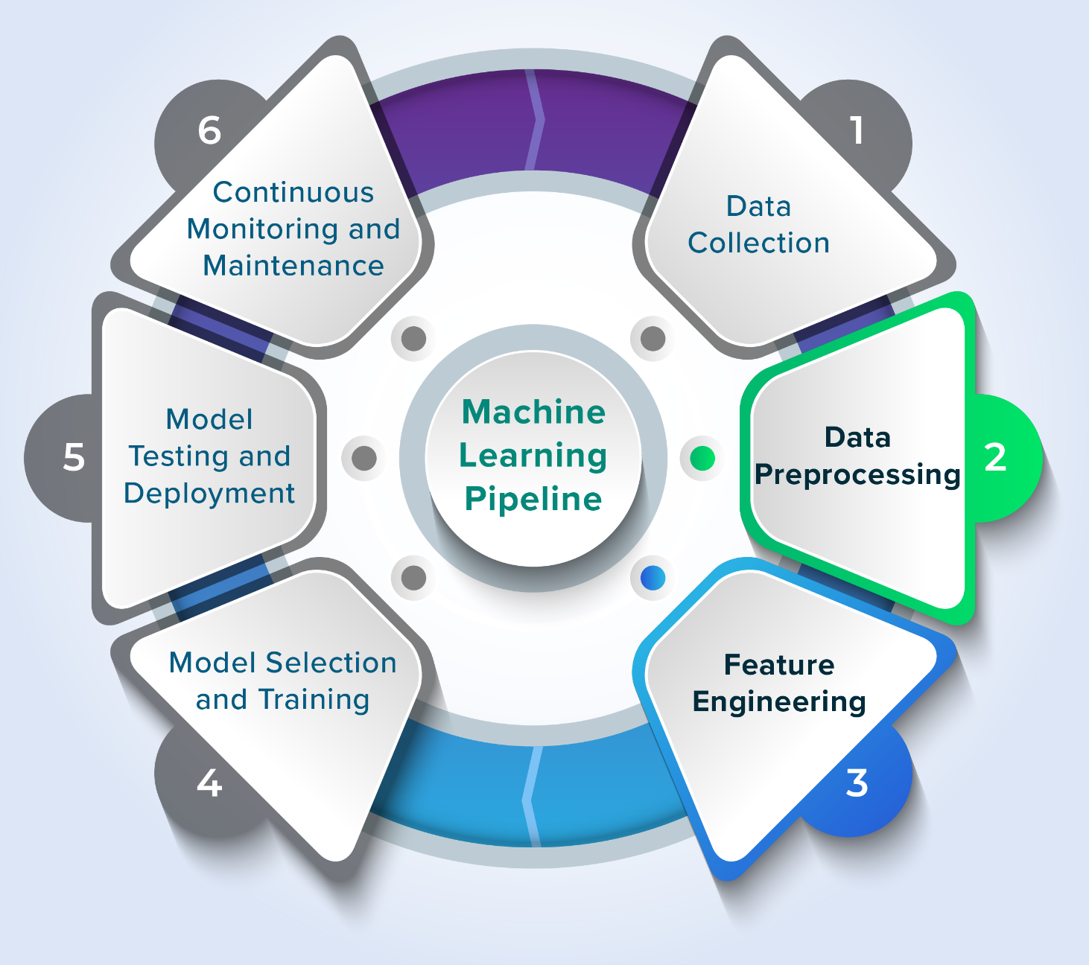
Figure 1: Data Preprocessing Pipeline

2. Week 2 Module: Exploratory Data Analysis (EDA)

Description:
Participated in "Exploratory Data Analysis (EDA)" session focusing on understanding data distributions, relationships, and patterns through statistical analysis and visualization.

Key Topics Covered:
- Statistical summary (mean, median, std, quantiles)
- Data distribution analysis (histograms, box plots)
- Correlation analysis and heatmaps
- Identifying patterns and trends in data
- EDA best practices and reporting
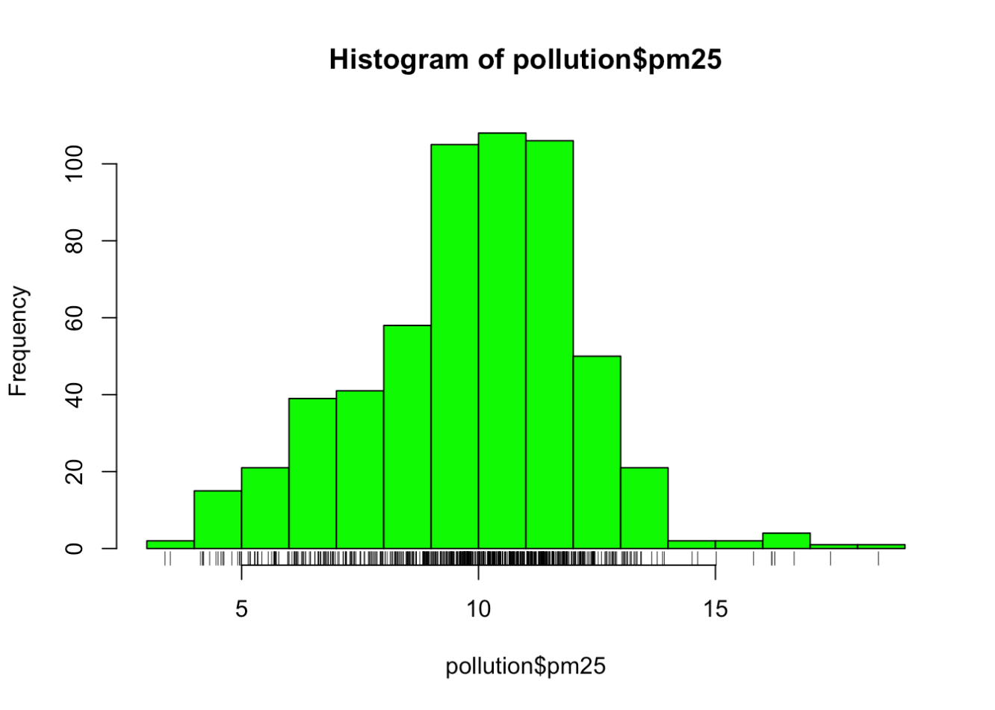

3. Week 2 Module: Data Visualization with Matplotlib & Seaborn

Description:
Completed "Data Visualization" module learning to create effective visualizations for data communication using Python libraries Matplotlib and Seaborn.

Key Visualizations Learned:
- Line plots for time-series data
- Bar charts for categorical comparisons
- Scatter plots for relationship analysis
- Heatmaps for correlation matrices
- Box plots for outlier visualization
- Customizing plots (titles, labels, colors, legends)
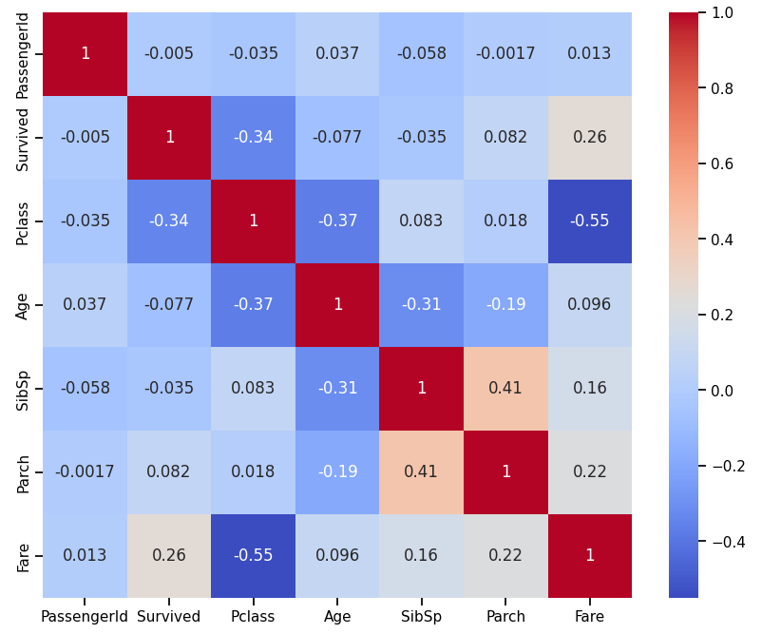

4. GTU Project Ideation and Planning (Border Defence Domain)

Description:
Finalized project idea for GTU internship under "Border Defence and Surveillance" problem domain. Conducted detailed planning session and created project roadmap.

Project Title:
"AI-Powered Border Surveillance System with Real-Time Anomaly Detection and Cloud-Based Alert Management"

Work Completed:
- Analyzed GTU problem statement requirements thoroughly
- Researched existing AI-based surveillance solutions
- Identified suitable public datasets (UCF-Crime, xView, DOTA)
- Defined project objectives using YOLOv8 and Ensemble ML
- Planned Azure Cloud deployment and Power BI dashboard
- Created 12-week implementation timeline
- Drafted project proposal outline
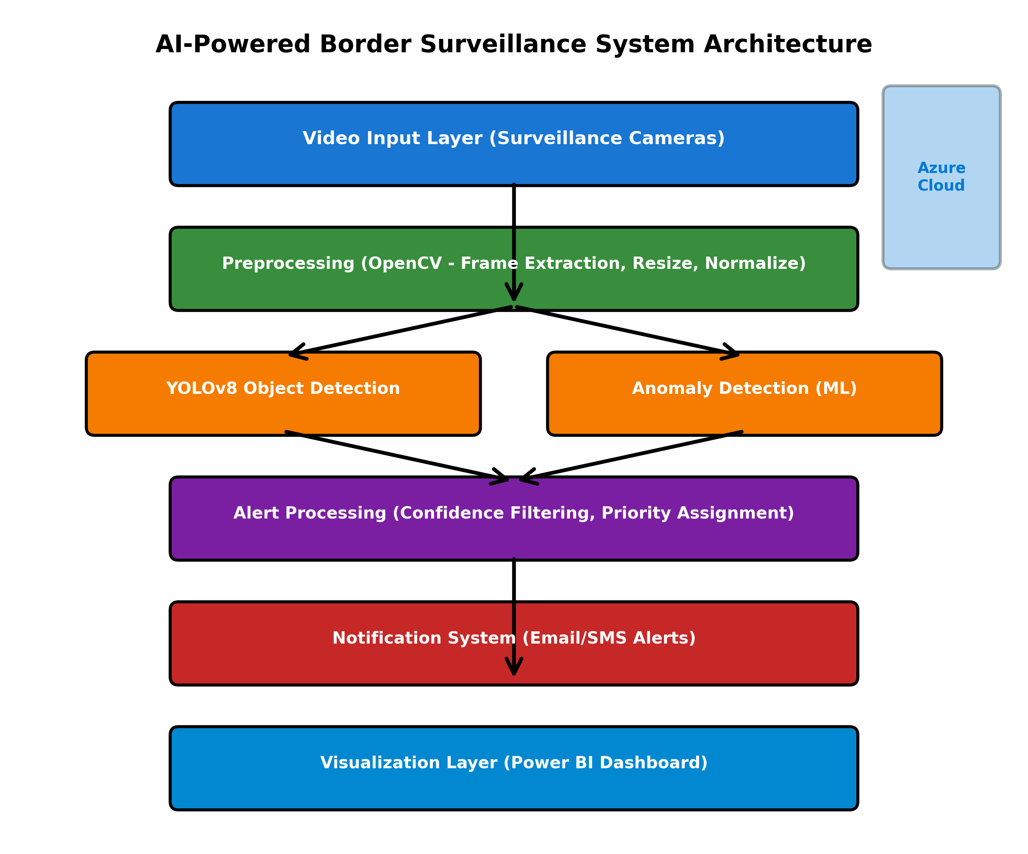
Figure 2: AI-Powered Border Surveillance System Architecture

5. Research on Datasets and Technologies

Description:
Conducted research on available datasets for border surveillance and object detection, as well as relevant technologies and frameworks.

Datasets Explored:
- UCF-Crime Dataset: 1,900 videos with 13 anomaly types for training anomaly detection models
- xView Satellite Dataset: 1 million+ annotated objects in 0.3m resolution satellite imagery
- DOTA Dataset: 280,000 annotated objects in 15 categories for aerial detection

Technologies Researched:
- YOLOv8: Latest object detection architecture with 30+ FPS processing
- Azure Functions: Serverless computing for video processing
- Azure Blob Storage: Scalable video/image storage solution
- Power BI: Interactive dashboard for real-time alerts and analytics

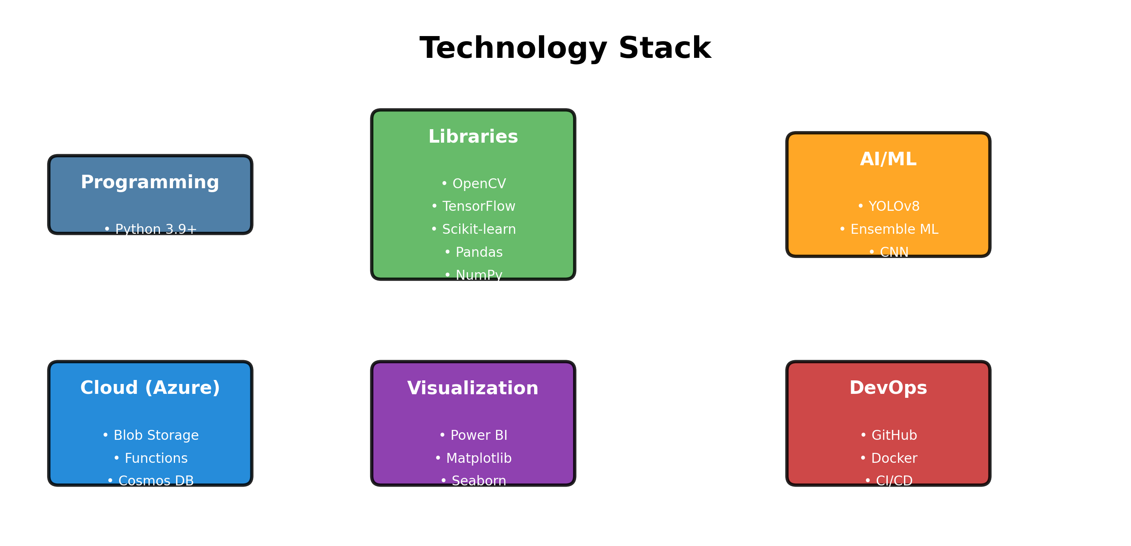
Figure 3: Complete Technology Stack for the Project

6. Internship Presentation Preparation

Description:
Started preparing presentation for 2-week progress review. Created comprehensive slides covering company profile, project proposal, methodology, timeline, and expected outcomes.

Presentation Outline Created:
- Company Profile & Microsoft Elevate Learning Modules (Week 1-12 structure)
- Problem Statement addressing Border Defence challenges
- Project Title and Applicability to national security
- Technical Objectives with measurable success metrics
- System Architecture showing data flow and processing layers
- Tech Stack (Python, YOLOv8, Azure, Power BI)
- 12-Week Timeline with detailed weekly milestones
- Deliverables and Success Metrics (>90% accuracy, <20% false positives)
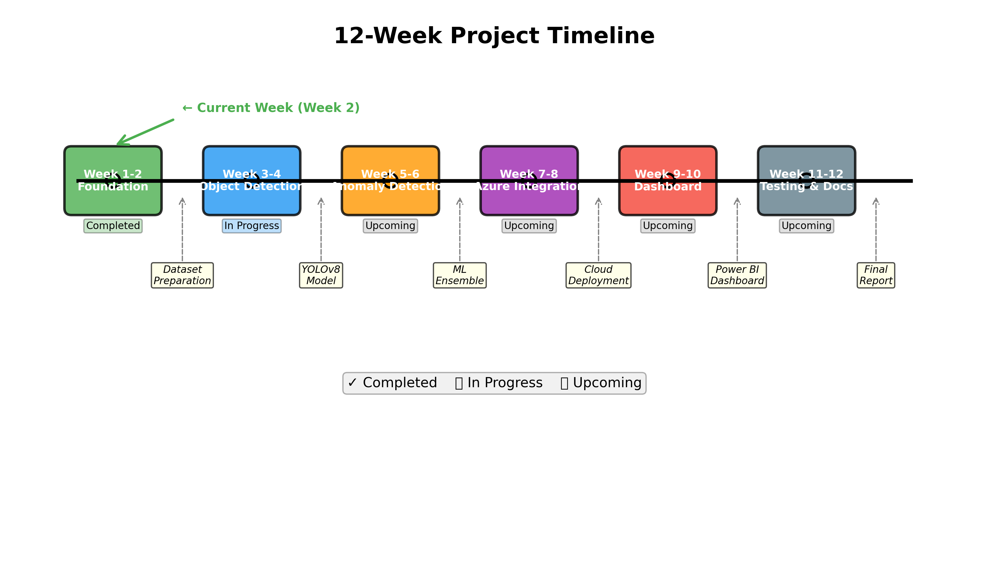
Figure 4: 12-Week Project Implementation Timeline

Plans for next week:

1. Complete Week 3 Microsoft Elevate Modules
- Attend "Power BI Fundamentals" live session
- Learn Power BI Desktop interface and data connections
- Practice creating basic visualizations in Power BI
- Understand Data Modeling concepts

2. Begin Dataset Preparation
- Download sample UCF-Crime dataset (start with 20-30 videos)
- Setup organized folder structure (Data/raw, Data/processed)
- Create dataset documentation (metadata, characteristics)
- Test basic video loading and frame extraction using OpenCV

3. Azure Account Setup and Exploration
- Register for Azure for Students account (free credits)
- Explore Azure portal interface
- Learn about Azure Blob Storage for video storage
- Understand Azure Functions basics for serverless processing

4. OpenCV Learning and Practice
- Complete OpenCV tutorial for video processing
- Practice frame extraction from videos
- Learn basic image preprocessing (resize, normalize)
- Test performance on sample surveillance videos

5. GitHub Repository Setup
- Create GitHub repository: "Border-Surveillance-AI"
- Setup proper folder structure (Data/, Notebooks/, Scripts/, models/)
- Write comprehensive README.md with project overview
- Initialize .gitignore for Python projects

Total Working Hours: 35 hours
Signature of Student: _____________________
The above entries are correct, and the grading of work done by Trainee is:
Excellent | Very Good | Good | Fair | Below Average | Poor
☐ | ☐ | ☐ | ☐ | ☐ | ☐

Signature of External Guide with Company Seal:
Date: 14/01/2026
Signature of Internal Guide: _____________________
Date: 14/01/2026

